

ORIGINATOR: CHIEF CONSTABLE

PAPER NO: AP23/36

SUBMITTED TO: ACCOUNTABILITY AND PERFORMANCE PANEL -
7 JULY 2023

SUBJECT: WORKFORCE REPORT

SUMMARY:

1. A workforce summary which is provided six monthly to the Panel, including Workforce Numbers, Diversity and Learning and Development.

RECOMMENDATION:

1. The Police and Crime Commissioner (PCC) is asked to consider the progress made by the Constabulary and raise issues with Chief Constable as appropriate to the PCC’s role in holding the Chief Constable to account.

DETAIL OF THE SUBMISSION

1. KEY ISSUES FOR CONSIDERATION

  - The purpose of this report is to provide reassurance regarding how the Constabulary attracts, recruits, retains, and develops its capacity and capability to provide an effective police service, and manages and understands its workforce, to deliver its duty of care as an employer and meet the needs of the organisation. As an additional element for consideration in this report, attrition rate analysis has been provided as following a request at the Accountability and Performance Panel on 8 July 2022.

  - This report supports the Police and Crime Plan commitment in that the Constabulary will:

- Develop the professionalism and diversity of the workforce by:

  - Focussing on attraction, recruitment, retention and workforce development.
  - Making the workforce more representative of the communities it serves.
  - Delivering the requirements of the Policing Education Qualifications Framework.
- Ensure the approach to people management supports the health, well-being and welfare of the workforce.
- Provide opportunities for young people through apprenticeships, internships and graduate opportunities.
- Make best use of volunteers to support and improve capacity and capability.

2. WORKFORCE NUMBERS

2.1 As at the end of April 2023, the Constabulary had a police officer establishment of 1,353, and a strength (FTE (full time equivalent)) of 1,334. In terms of strength, this is an increase of 22 FTE on the figures at the end of November 2022. Workforce Planning forecast the strength at the end of this financial year to be 1,364.

2.2 The Police Community Support Officer (PCSO) establishment at the end of April 2023 was 40.2 and there was a strength (FTE) of 31.9. This is a constant in the establishment level, and a decrease of 5.1 (FTE) from the reporting point in November 2022.

2.3 The police staff establishment was 1,036.8 at the end of April 2023, and there was a strength (FTE) of 924.4. The strength has seen a small increase since the last reported data in April 2022, with an increase of 19.3 FTE.

2.4 The Constabulary met its target in Spring 2023 for the recruitment of police officers as part of Project Uplift.

3. WORKFORCE DIVERSITY

3.1 Data as at the end of April 2023 shows that the percentage of officers who have shared with us that they are Black, Asian and Minority Ethnic (BAME), which is how data is reported to the Home Office as part of Project Uplift, is 2.8%, which has remained stable over the past five years. This also shows no movement against the 2.8% reported rate in April 2022. The proportion of officers who have shared with the Constabulary that they are from any other white background has increased from 1.4% five years ago to 1.9%, this is however a reduction from the 2.3% reported in April 2022. The proportion of officers who have not provided this information to the Constabulary is now just 1.4%.

3.2 The proportion of staff who are BAME is 2.2%, a slight increase on April 2022 and the proportion of staff who identify as being from any other white background is 1.9%. The proportion of those who have not provided this information to the Constabulary is 4.6%, showing a decrease from the 5.9% in April 2022. The Constabulary is looking to address this via the “Safe to Say” campaign which is a national campaign to increase the proportion of those who share their protected characteristics with the Constabulary, providing the context on why this information is important and how it will be used.

3.3 The proportion of officers who are female has grown from 30.5% to 34.9% over the past five years. The proportion of police staff has grown from 63.2% to 63.6% over the same period. Both showing better representation of women within the Constabulary.

3.4 The proportion of officers who are under the age of 25 has increased to 14.0% from 6.0% five years ago. This is as a result of the increased number of recruitment intakes, and targeted recruitment and a lower average age of those applying and being selected.

3.5 The proportion of officers who identify as Lesbian/Gay or Bisexual has increased from 3.3% to 3.9% over the five years. The proportion of officers who have not shared this information with us has reduced from 37.6% to 23.0%. Owing to improved recruitment processes, the Constabulary is much more effective now in collecting the information from new recruits.

3.6 Officers that have shared with us that they have a disability is 2.9%, the number of individuals who have not shared this information with us has reduced from 38.6% to 21.7% over the last five years. The proportion of staff who have shared this information with us is 5.1%, the number of individuals who have not shared this information with us now sits at 23.5% compared with 31.0% five years ago.

4. DIVERSITY EQUALITY AND INCLUSIVITY AND POSITIVE ACTION

4.1 Jointly with Norfolk, the Constabulary has been working on the current Diversity, Equality and Inclusivity (DEI) programme of work in order to create a shared approach to managing DEI across the Constabularies. The internal DEI offering has been brought back into the Joint People Directorate to manage and work is ongoing to formulate a joint strategy capturing the direction of travel of both Constabularies. Work has been undertaken to:

- Create an overall strategy and action plan to outline the areas of focus for the Constabulary;
- Re-align the DEI boards across both Constabularies to ensure they are efficient and effective at monitoring and delivering against the overall DEI strategy and action plan;
- Provide a branded programme of work that all DEI project work and associated actions fall under;
- Ensure actions in line with the Violence Against Women and Girls and the Police Race Action Plan are recognised and achieved for the Constabulary, in conjunction with the work ongoing around DEI.

4.2 A dedicated Positive Action Advisor (PAA) is situated within Suffolk. Across the county, Positive Action events are now in place utilising stakeholder engagement and community relationships as well as higher education institutions and schools. Over the last year the PAA has delivered over 50 unique engagements at education institutions, attended 12 community job fairs across the county (run by the Council, the job fair, Department for Work and Pensions and MPs), created links with the Suffolk Job centres whereby attending 14 drop ins sessions and group talks, and delivered the first ‘Open Doors’ event outside Bury Police Station.

4.3 Dedicated recruitment events were held throughout the year for all underrepresented groups, providing information on the recruitment process as well as what individuals may expect from a career in policing. Jointly with Norfolk the PAAs have completed three series of police run workshops for Ethnic Minority, LGBT+, Disability and Neurodiversity, Women and DHEP & PPD. They have now engaged with a total of 640 external people from these backgrounds through these events alone. The Suffolk PAA is set to run the first in person recruitment open evening at PHQ in June.

4.4 The PAA supports every under-represented individual through the Suffolk recruitment process who applies to be a PC/DC through a dedicated mentoring programme. This includes contact (at minimum) at each stage in the recruitment process, general queries; characteristic related queries, recruitment process queries, 1:1 Email/ Microsoft Teams/Calls, invitations to bespoke webinars to support with the online assessment centre and board interviews, pre-employment support and onboarding/introductions to staff support networks upon joining. Since Uplift (January 2022 – May 2023) 31 candidates from marginalised groups (Ethnic Minority, LGBT+, Disability and Neurodiversity) have joined our force through Positive Action support and 65 Positive Action Candidates have started in Suffolk Police from May 2020 - May 2023.

4.5 Moving forwards, the PAA will now begin to focus on retention of marginalised groups internally, mentoring programmes and developing the work with the Staff Support Networks. They will be promoting specialisms alongside departments which lacks diversity and hosting bespoke events to support this, for example, women into the Roads and Armed Policing Team (RAPT).

5. CHANGING WORKFORCE AND ATTRITION

5.1 As stated above, the Constabulary has seen a high proportion of younger officers recruited than previously.

5.2 In addition to officers recruited via the regular intakes, 22 officers were recruited during the 2022/23 financial year, compared with the 11 recruited across the 2021/22 financial year. This took into account the transferee freeze which was imposed for Quarter 4 of the financial year. In April, one new transferee was appointed.

5.3 During this time, the Constabulary has observed a higher rate of attrition amongst those officers who are relatively junior in service. This is reflected nationally in officer numbers and is modelled and monitored though significant work within the Attrition Project to better understand all force leavers, the push and pull factors for joining, remaining and leaving Constabulary employment (i.e. economic, career development). Phone calls are now made to all employees who leave (officers and staff), with set questions in order to build an effective data picture. This data has continued to be reported to the Constabulary’s People Board, with the most recent summary of data collected and trends presented in December 2022.

5.4 The below charts show the percentage of the new starters with self-identified protected characteristics recruited as police officers. This is for 2022/23 and from a sample of 114 individuals.

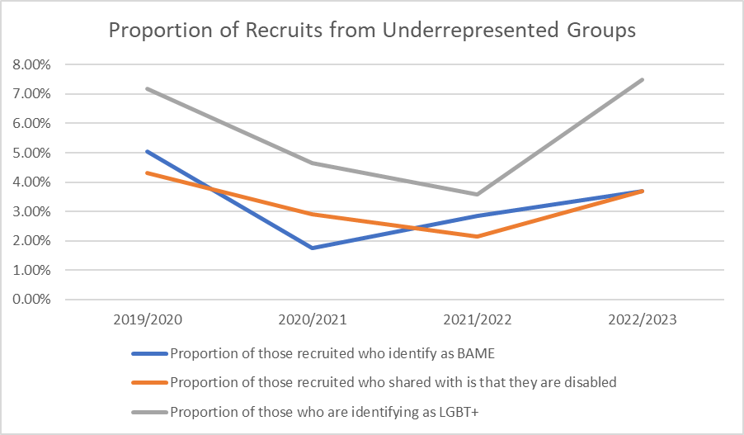

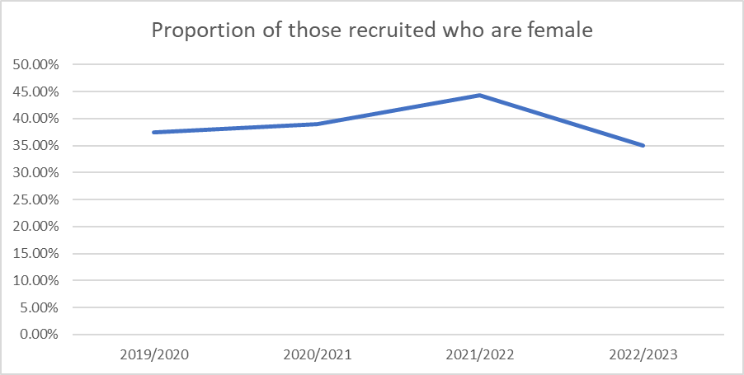

5.5 The Constabulary has continued to undergo the work around attrition in both staff and officers. A full review of the leaving information and feedback from leavers from the Constabularies over the 2022/23 financial year has now been conducted. The review considers officers and staff from both Norfolk and Suffolk Constabularies due to the similarities in responses.

5.6 The below graphics show the findings for officers only.

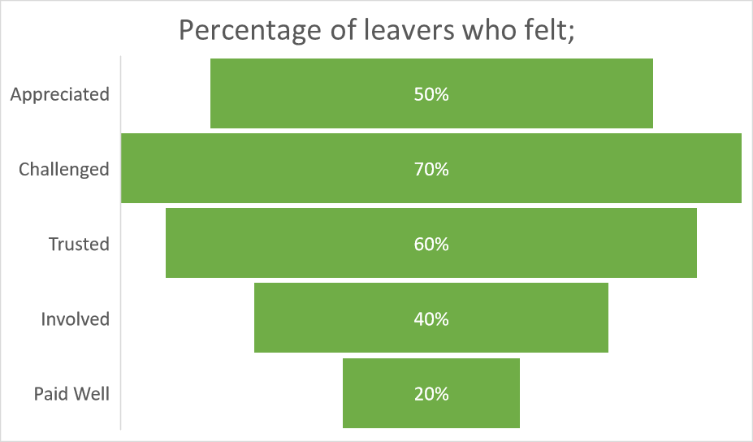

5.7 The below graphics show the findings for Staff only.

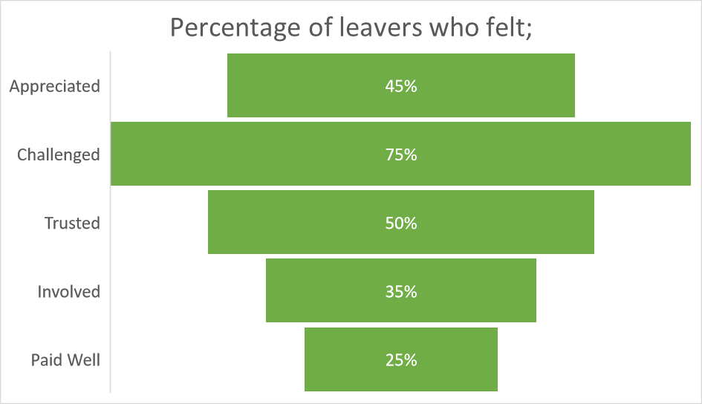

5.8 The work resulting from this, will be to look at forming a retention strategy based on the feedback from this attrition work. This will look at the areas of focus for both officers and staff to aim to increase the retention rates of both groups. The current process around gathering of information from leavers from the Constabulary will continue, ensuring any themes that develop are pulled out.

5.9 Some of the key feedback from both officers and staff is represented below. For officers, the most commonly reported reason was work-life balance, whilst for staff internal-progression was the mode reason given.
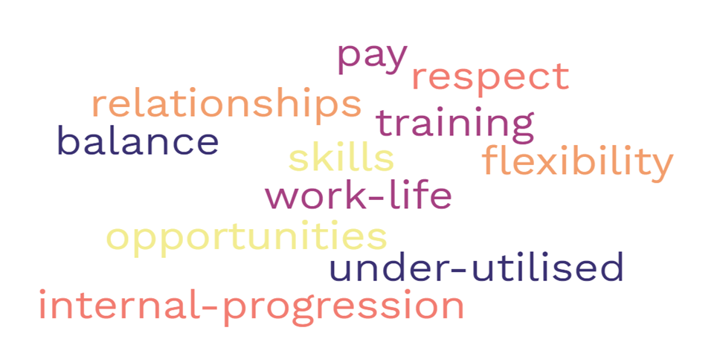

6. ABSENCE MANAGEMENT

6.1 The Constabulary remains committed to supporting the workforce with both their physical and mental wellbeing. The absence rates for the Constabulary remain low for the workforce, rates continue to be monitored to look out for any trends.

6.2 Amongst Suffolk Officers, the year-to-date absence rate for Suffolk County Policing Command (CPC) in 2022/23 was 5.4%, whilst for Suffolk Crime, Safeguarding and Incident Management Command (CSIM) the year-to-date absence rate is 3.7%. For Suffolk Police Staff, the year-to-date absence rate for Suffolk CPC is 7.5% and for Suffolk CSIM the year-to-date absence rate is 5.8%.

6.3 The Constabulary actively manages officers who are on Limited Duties. Limited Duties are categorised as either Recuperative Duties or Adjusted Duties. The definition of Recuperative duties is as follows:

“duties falling short of full deployment, undertaken by a police officer following injury, accident, illness or medical incident, during which the officer adapts to and prepares for a return to full duties and the full hours for which they are paid, and is assessed to determine whether he or she is capable of making such a return.”

6.4 As at the end of April there were 138 officers on recuperative duties. These duties may have non-obtrusive restrictions, but do give officers the opportunity to return to the workplace.

6.5 Adjusted Duties are defined as follows:

“duties falling short of full deployment, in respect of which workplace adjustments (including reasonable adjustments under the Equality Act 2010) have been made to overcome barriers to working”.

6.6 As at the end of April there were 173 limited duties officers. Of these officers on limited duties, 35 are currently on adjusted duties whilst 138 are currently on recuperative duties. There is now an enhanced data set which provides greater scope for commanders to make decisions as to where adjusted duties officers can be accommodated where they can make the fullest contribution.

7. POLICY DRIVERS

7.1 The Covid-19 pandemic has been a catalyst for the adoption of new ways of working across the Constabulary. An increase in flexible ways of working is being pursued by the Constabulary in line with wider workforce trends. This is being managed by the Modern Workplace programme, with support from the Human Resources Department. New contracts with role categorisation for affected police staff are being rolled out to staff.

7.2 The Chief Constable has made the decision to introduce Targeted Variable Payments this year. The target of these will be detectives in Professionalising Investigation Programme Level 2 (PIP2) designated posts, given that this has been a challenging area for the Constabulary to retain skills in the past. Commands have identified these posts that should attract the payments, these were paid to eligible officers and staff in October 2022 and continue to be done so on a monthly basis.

8 LEARNING AND DEVELOPMENT

8.1 The Constabulary is now in the second year of PEQF delivery, the first year has seen positive progress both the student experience and the partnership with Anglia Ruskin University. Early evidence suggests that students feel better supported on the PEQF programmes compared to the old Initial Police Learning & Development Programme (IPLDP) and attrition and interventions are lower on the new programme.

8.2 The old entry pathway, IPLDP, has been extended by the College of Policing (CoP) until 31 March 2024. It has recently been used to support a Fastrack Direct Entry Detective Cohort that commenced March 2023. There are no further plans to use IPLDP and the force will await further information from the CoP on the new 4th Entry route before deciding if and how to integrate this with our existing entry routes. The force will, however, begin to explore opportunities for a Part Time PEQF entry route.

8.3 We have seen the completion of a new large classroom on site to meet continuing student officer demand and continue to use other sites across the force to accommodate other training (Specialist crime courses).

8.4 The new E-PDR platform is reaching the end of the first year and work is being done through the People Board to achieve more consistent compliance rates across the departments. The E-PDR will continue to be developed to include opportunities for proactive data collection to support talent management and succession planning strategies.

8.5 The use of the Constabulary digital learning platform the ‘Best I Can Be’ continues to develop providing learning opportunities at the point of need. Demand for in-house design has grown and stakeholders are actively engaged with developing interactive learning programmes. This platform will be used to host all Athena related modules and national mandated learning packages associated with the Violence against Women and Girls (VAWG) and the Police Race Action plans.

8.6 Protected Learning Time (PLT) has been a challenge under the Policing Education Qualifications Framework (PEQF) and we have actively sought to mitigate the impact on our force. Working in partnership with Anglia Ruskin University we have significantly reduced the PLT by redesigning the year 2 delivery model. Work continues with the CoP on further PEQF optimisation, the Head of Learning and Development is involved in this work and is progressing the improvements to PLT, End Point assessment, vocational nature of this degree and standardisation of ‘Value for Money’ from University providers. The Learning and Development Department will be piloting a more structured approach to wider PLT with the Strategic Business and Operational Services Team, and this will be launched in May 2023.

8.7 The professionalisation of policing skills through the increased level of licensing of locally delivered training undertaken on behalf of the College of Policing is a new and emerging challenge to the Constabulary. Local and national events (e.g., Manchester Bombing) frequently refer back to the training delivered to officers and whether this is consistent across the country.

8.8 The College of Policing are, through a licensing approach, now able to set a standardised baseline of competence in relation to driving, use of force (taser and firearms) and first aid. This will increase to the areas of personal safety training and Joint Interoperability training over the coming year. Each of these standards are assessed via national auditing and licensing scrutiny enable the College of Policing to standardise learning so that personal and organisational liability is clear. This replicates the demand and energy that goes into supporting HMIC&FRS inspections into additional requirements that fit the College of Policing audits of training licences.

8.9 The Constabulary continues to develop the Chronicle System to ensure robust training and accreditation records are aligned to the differing standards across the various licensed policing skill areas. This supports skills monitoring, compliance, and capability, significantly improving the position from when the original His Majesty's Inspectorate of Constabulary (HMICFRS) AFI (Area For Improvement) was set. The system has now been extended to cover all licensed activity from the College of Policing as well as its likely trajectory over the next few years. This programme also enables the key aspects of skills to be achieved:

- Single source of reference;
- Improved data accuracy;
- Better reporting of compliance;
- Better understanding of the costs;
- Steering the development of data to enhance future decision making for example skills distribution and succession planning.

8.10 Performance is being achieved and is on an upward trajectory in relation to skills compliance, which has previously been a risk for the Constabulary.

9. FINANCIAL IMPLICATIONS:

9.1 There are no Financial Implications associated with this report.

10. OTHER IMPLICATIONS AND RISKS

10.1 There are no other implications and risks associated with this report.

11. CHIEF OFFICER CONCLUSION

  - Suffolk Constabulary is a great place to work and attracts great people who want to make a difference for our county. Alongside recruiting and retaining staff into CCR, the recruitment and retention of police officers, both new and in transfers from other Forces, to maintain police officer numbers at historic high levels for Suffolk, is a priority for the Constabulary. This includes active marketing campaigns, providing focused support to improve diversity, and making our excellent Anglia Ruskin University PEQF programme as good as it can be.

  - We have excellent relationships with all our Suffolk colleges and a productive pipeline through our cadets, police staff and special constabulary. We are also actively planning for the future: this includes developing attractive career pathways into detective and other specialist roles in Suffolk, identifying potential early for future leadership development and, in the longer term, we are exploring options for part time entry to be an even more attractive employer. We have recently recruited two highly qualified people into our HR team to key positions: a senior role as Head of Recruitment and an experienced Recruitment Manager. This succession planning will further strengthen our team and enable us to remain competitive in a difficult market.

