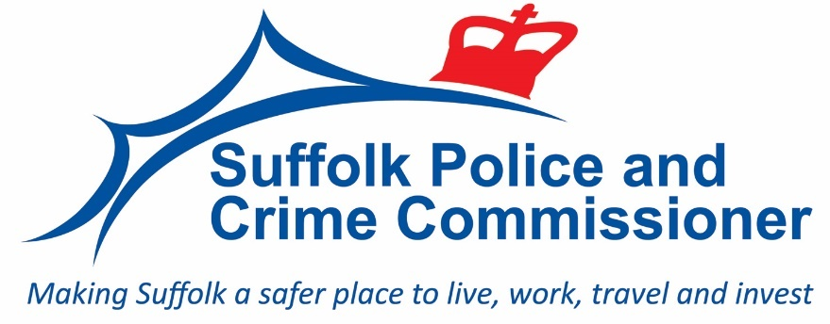

ORIGINATOR: CHIEF CONSTABLE

PAPER NO: AP23/32

SUBMITTED TO: ACCOUNTABILITY AND PERFORMANCE PANEL -
7 JULY 2023

SUBJECT: IMPROVING CONFIDENCE AND SATISFACTION

SUMMARY:
1. This report illustrates Constabulary activity and performance in respect of public confidence in policing and the satisfaction of victims.

RECOMMENDATION:

1. The Police and Crime Commissioner (PCC) is asked to consider the progress made by the Constabulary and raise issues with Chief Constable as appropriate to the PCC’s role in holding the Chief Constable to account.

- INTRODUCTION
  - The Police and Crime Plan focuses on victims, and the service they receive. The Plan specifies under objective 3 (engagement with the public) a commitment that the PCC will consider detailed reports at the PCCs Accountability and Performance Panel on victim satisfaction and public confidence.

  - Victim satisfaction relates to the views and experiences of victims of certain types of crime reported to Suffolk Constabulary. In Suffolk, a third-party research company is used to conduct telephone interviews with victims of:
- Hate Crime
- Rural Crime
- Online Crime
- Business Crime

  - Survey results have been available each month and are usually reported as rolling satisfaction rates over the prior 12 months to ensure sufficiently small margins of error.

  - Like most forces, Suffolk Constabulary has traditionally used the Office of National Statistics Crime Survey of England and Wales (CSEW) to track the confidence of the Suffolk public. As a result of restrictions imposed due to Covid-19 the CSEW surveys were conducted by telephone between May 2020 and October 2021. There has been no CSEW confidence data published since the period ending March 2020 due to the impact on the comparability of the reduced sample size with the historical data. A phased reintroduction of the face-to-face CSEW began in October 2021 to enable a return to full topic coverage in time.

  - Surveys of a similar nature are also undertaken with victims of Domestic Abuse (as part of the Home Office mandated ADR 444) however these are undertaken by the in-house Domestic Abuse Victim Satisfaction Survey Co-ordinator due to the sensitivities of the crime and with victim safeguarding as the primary consideration.

  - This paper outlines the current position in respect of victim satisfaction, as well as detailing several of the key programmes of activity the Constabulary is operating to sustain and improve performance in these areas.
- VICTIM SATISFACTION DATA
Since April 2017 forces have been able to choose the victim groups they survey based on what they felt were most appropriate, with the stipulation that all forces would survey victims of Domestic Abuse. Since then, Suffolk Constabulary have surveyed the following victim groups:
- Hate Crime
- Rural Crime
- Online Crime
- Business Crime
- Domestic Abuse (Home Office mandated)
In relation to the following satisfaction measures
- % of victims satisfied with overall service
- % of victims satisfied with accessibility
- % of victims satisfied with actions taken
- % of victims satisfied with treatment
- % of victims satisfied with how well they were kept informed
Hate Crime, Online Crime, Rural Crime and Business Crime
  - For hate crime, online crime, rural crime, and business crime the Constabulary awarded a contract to the research company SMSR in June 2017, which was renewed in 2020 for another operating term. Data for the twelve-month rolling period to April 2023 is displayed in Table 2 below, alongside comparable data from the previous report which covers the period up to October 2022 (table 1).

  - It is not possible to compare levels of satisfaction with other police forces as each force will be surveying different victim types, in different ways. However, with the ability to make year on year comparisons with local data we can now track progress internally, which is helped by the rise in the number of surveys completed in a twelve-month period.
  - Satisfaction across all measures for the four survey groups combined has increased compared to the previous 12 months and the 12 months to October 2022.

Table 1: Victim satisfaction up to October 2022 Table 2: Victim satisfaction up to April 2023
  - Satisfaction with first contact has increased for all crime areas when compared to the previous 12 months. This compares to a fall in satisfaction in this area in April 2022 which ranged from 2.7pp for hate crime to 16.9pp for rural crime. Overall satisfaction with first contact is at 4.2pp higher than in the previous 12 months.

  - In contrast to increases in satisfaction seen for other crime types, a decrease in satisfaction was seen across all measures, except first contact, for victims of rural crime. Satisfaction with the whole experience for victims of rural crime decreased by 5.3pp to 78% in comparison to the previous twelve months.

  - The general trends over time show fluctuation across the five satisfaction measures (see charts 1-5 below).

Figures 1-5: Satisfaction levels from 2019 to date for the four crime types combined.
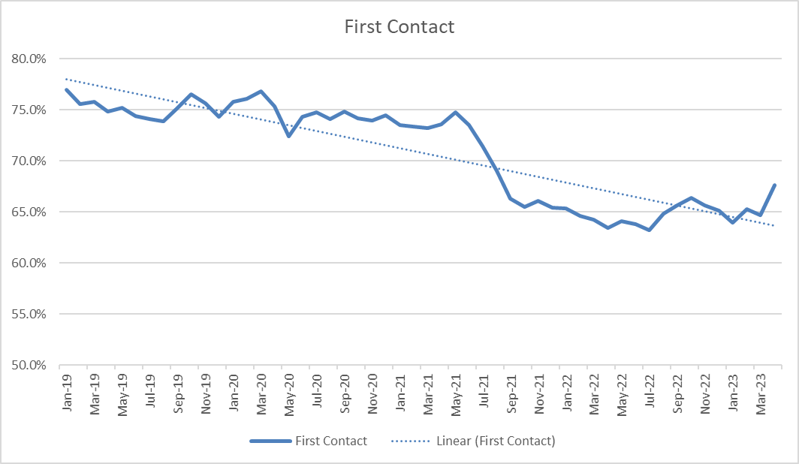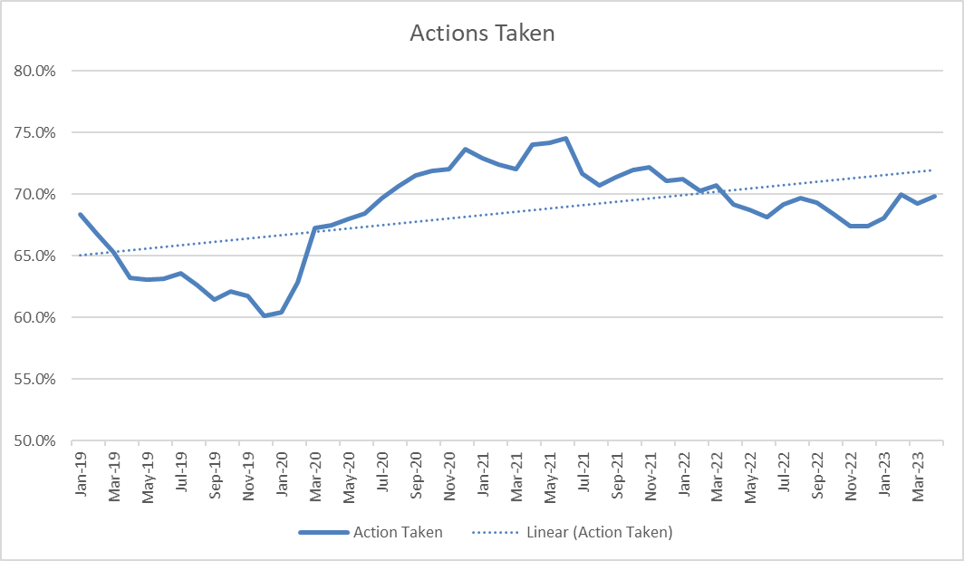
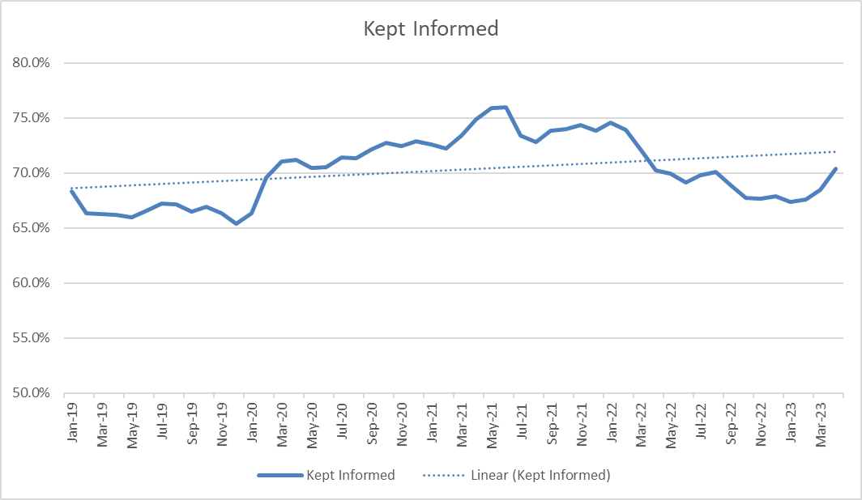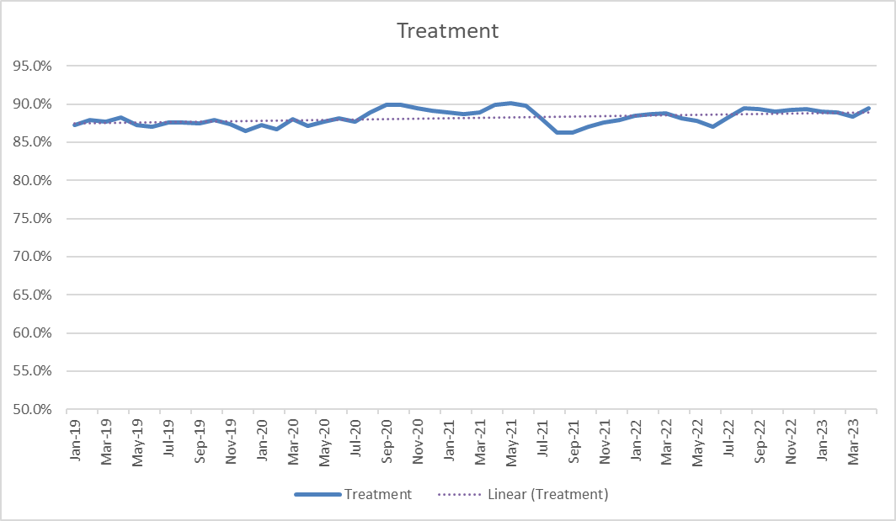

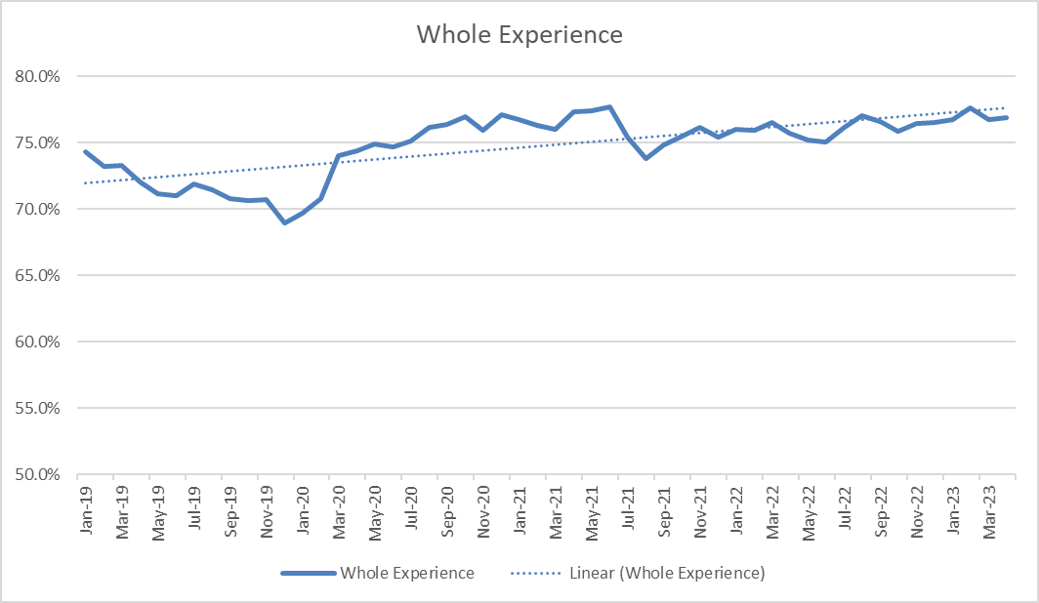
Assessment of the Data
  - First Contact - Current levels of satisfaction with first contact are lower than at any time since January 2019. However, satisfaction in this area has been increasing in recent months. A key area of focus for the Constabulary continues to be the effectiveness of how we manage initial contact with victims of crime and those calling for our service. There continues to be a considerable investment into the Contact and Control Room (CCR) environment, which the data would tend to suggest is starting to have a positive impact and contributing to the satisfaction improvements in this area.

  - Action Taken - The level of satisfaction with the action taken reached its highest point in June 2021, and for the last 12 months has been consistently higher than previous years. However, despite a fall in late 2022 levels have been rising since January 2023. There is likely to be a direct correlation between the perception of how successful the Constabulary is being at “taking action”; and its ability to achieve successful outcomes within the Criminal Justice System. Whilst the Constabulary continue to promote a need to strive for positive investigative outcomes amongst our staff and have invested significantly in upskilling the investigative standards of our officers in recent months; we continue to face challenges with delays in achieving outcomes for victims at court due to significant demand on the entire criminal Justice system.

  - Keep Informed - The level of satisfaction with how victims were kept informed reached its highest point in June 2021. Levels of satisfaction have been falling in this area since early 2022, however the most recent data shows an uptick in satisfaction over the last two months. The Constabulary now track Victim Code of Practice (VCOP) compliance performance at a team level this features in as part of monthly Crime Audits. This closer monitoring is allowing the identification of areas for improvement in training, and the development of Athena/OPTIK based improvements which will drive consistency in updates, particularly for victims of crime.

  - Treatment - Satisfaction with treatment by police has increased in recent months and it remains at a high level compared to all other satisfaction measures. Following a fall in overall satisfaction with the whole experience in summer 2021, gradual increase over time means levels are now back to those seen in late spring 2021.
Domestic Abuse Surveys (ADR 444) and Sexual Offences
  - Suffolk Constabulary has a requirement to comply with ADR444 (Service Improvement Survey – Domestic Abuse). In Suffolk, a Victim Satisfaction Survey (VSS) Co-ordinator delivers the Home Office mandated requirement to carry out satisfaction surveys with victims of Domestic Abuse. Data from the Domestic Abuse surveys is recorded and stored on an in-house database which allows analysts from the Strategic, Business and Operational Services (SBOS) department to access the results and review for a variety of purposes including to inform the Domestic Abuse Delivery Board.

  - The Constabulary has data for a full two-year period so year on year comparisons is included below. The proportion satisfied reflects those that gave a satisfied response (fairly satisfied, very satisfied or completely satisfied) in the 12-month period to 31 March 2023 and compares this to the preceding 12-month period. In general terms satisfaction in these areas is improving.
The key findings are:

- 100% satisfied with the first contact they had with police (+10pp)
- 96% satisfied with the initial service received from the attending officer (+7pp)
- 88% satisfied with the way they were kept informed (-5pp)
- 93% satisfied with the treatment they received (+2pp)
- 91% satisfied with their overall experience (No Change)

- PUBLIC CONFIDENCE, SATISFACTION AND ENGAGEMENT BOARD
  - The Constabulary’s Public Confidence, Satisfaction and Engagement Board is led by the Assistant Chief Constable for Local Policing. This Board commissions specific research on public confidence and satisfaction and meets bi-monthly to explore the main themes in greater depth each month and to set priorities and direction.

  - The Board has enabled the Constabulary to scrutinise key data to understand how the communities of Suffolk perceive their interactions with the force. It has provided a forum to respond effectively locally to national public confidence challenges like Violence Against Women and Girls (VAWG) and Black Lives Matters (BLM). It is currently scoping work, with support from Ipswich and Suffolk Council for Racial Equality (ISCRE) and others, into reducing the “confidence gap” between different communities in policing as part of Suffolk’s Race Action Plan. Progress in relation to this will be reported to future boards.

  - The following provides a summary and context of the key activities that are being overseen by the Public Confidence, Satisfaction and Engagement Board.

CCR Improvements (First Contact)
  - The Constabulary continues to recognise the impact effective management of our calls for service has upon Public Confidence and Satisfaction and particularly First Contact. This remains a key priority area that is being reviewed by the Public Confidence, Satisfaction and Engagement Board. The Constabulary continue to focus heavily on a program of improvement in this business area and a separate full report on Responding to Calls for Assistance has been submitted by way of update.
Community Engagement Activity (Keep Informed, Action Taken)
  - Operationally, community engagement continues to be driven by the Community Engagement Officers (CEOs). CEOs continue to support their local priorities and are briefed daily on any emerging concerns or crime patterns. The CEOs actively post upcoming events, local activity and results on social media and respond to calls for service (CFS) via this forum.

  - Our External Constable’s County magazine has been re-designed to include more information about where to meet our teams, responses to public concerns and the area priorities. The first edition of this updated version was published at the end of May and was made available in print at the Suffolk Show on 31 May 2023 and 1 June 2023.

  - A trial programme for the re-introduction of “Beat officers” in Lowestoft has been concluded with some good results. The public feedback has been positive to have a named contact to approach and to invite into their community activities and meetings. This has been supported by the CEO for the area who has promoted their activities on social media for the wider community to be aware of. This will feed into the new Operating Model.

  - The Kestrel Teams’ continue to deploy to areas of most need and have significantly improved our capacity and capability for engagement.

  - With the introduction of the new Community Policing Teams, we are building an Engagement Toolkit that will be available to all officers to assist with improving their connectivity with their communities and know who the right person is to contact. The toolkit will also highlight alternative methods of Engagement. This work forms part of the planning by the Neighbourhood & Partnership Team for the new Operating Model that is due to be implemented in December 2023. Our aim is to upskill all officers in the Community Policing Teams to ensure they are well informed and trained to deliver to the highest standards to their community.
Support for National Campaigns (Action Taken, Keep Informed, Treatment)
  - We continue to support local and national campaigns such as including the Neighbourhood Policing Week of Action, the Op Sceptre campaign being run in May 2023 and we are planning for the Women’s World Cup in July 2023. The focus will be on raising awareness of key issues, giving crime prevention advice, and highlighting the excellent work that staff are doing within Suffolk.
Social Media (Keep Informed)
  - The data shows that our Social Media following is continuing to grow across the County and on all three platforms currently used, with Facebook now passed 96,000 followers, Twitter approaching 80,000 and Instagram over 23,000. There is good engagement with our activity and a good response rate to issues raised. The shift to a more personal style of communication has continued with members of the public connecting with our office.
Prevention/Violence against women and girls (Action Taken, Keep Informed, Treatment)
  - The new Prevention Strategy has been launched which has been well received. We continue to embed this within the Constabulary, including across the County Policing Command (CPC) Teams and some bespoke training within the CCR. The First Principal information has been refreshed and highlighted to Call Takers so that they can signpost people to our website to gain a wealth of information. We have introduced Prevention Activity Logs (PALs) into front line policing to capture all the prevention work being done but also to capture the work done on emerging issues to not only ensure that these issues are highlighted but to provide an accessible record of work which can be referenced in other areas. We have linked our problem-solving training and rolled out Continuous Professional Development (CPD) to all Inspectors and Sergeants and to new Student Officers.

  - We have a summer prevention and engagement plan focussed on keeping people safe, protecting people from harm, and preventing crime in partnership. We will achieve this through engaging with our communities, listening effectively to their issues or concerns and working together with communities and partners.
Police Race Action Plan (Action Taken, Treatment)
  - Suffolk Constabulary are committed to delivering positively against the key objectives of this national plan and recognise that independent scrutiny and oversight of our delivery is an essential aspect of achieving success.

  - The Constabulary are seeking to develop an Advisory & Scrutiny Panel which will act in an advisory/critical friend capacity, but also ensure through challenge and scrutiny that Suffolk Constabulary is delivering effectively against the principles and promises to set out within the National Plan. The Advisory & Scrutiny Panel will consist of an Independent Chairperson, Suffolk Constabulary Staff Associations and including 3 Independent Panel members.

  - In the absence of a revised National Police Race Action Plan (PRAP), under the leadership of the Deputy Chief Constable Suffolk Constabulary has developed a Suffolk Race Action Plan that will contribute towards the establishment of an anti-racist police service, that proactively seeks to tackle racial disparities in policing, does not exacerbate racial disparities that may exist elsewhere in society, and is continually alive to issues of race and racism.

  - The Public Confidence, Satisfaction and Engagement Board continues to monitor ways in which we deliver positive engagement relating to the PRAP, both internally and externally. Future work to be overseen by this board will include a series of internal promotion workshops aimed at raising the awareness of the Plan and helping to establishing a clear baseline of current performance against it.

PUBLIC COMPLAINTS
  - Public complaints are made by members of the public in relation to the conduct of those serving in the Force and are recorded under Schedule 3 of the Police Reform Act (PRA) 2002.

  - The Policing and Crime Act 2017 made significant changes to the police complaints system to achieve a more customer-focussed complaints system. From 1 February 2020 Forces were required to log and report complaints about a much wider range of issues including the service provided by the police as an organisation, handled outside of Schedule 3 of the PRA 2002.

  - The data included here is extracted from the Professional Standards department live case management system, Centurion. There are several terms mentioned in this section, which for ease of reference are explained below:

- Schedule 3: The complaint must be recorded and handled under Schedule 3 of the legislation if the complainant wishes it to be or if it meets certain criteria as defined within the guidance.
- Outside of Schedule 3: The complaint can be logged and handled outside of Schedule 3 with a view to resolving the matter promptly and to the satisfaction of the complainant without the need for detailed enquiries to address the concerns.
- Complaint: Any expression of dissatisfaction with police expressed by or on behalf of a member of the public. Nationally complaints are grouped under specific categories and sub-categories as directed by the Independent Office for Police Conduct (IOPC).
- Allegation: Complaints are made up of allegations. Alleged behaviour from officers/staff which has resulted in dissatisfaction and a complaint can contain any number of allegations.
Public Complaints in Focus (Action Taken)

4.4 During the period 1st April 2022 to 31st March 2023, a total of 362 complaints were received. Of these complaints, 301 were recorded under Schedule 3 and 61 were logged outside of Schedule 3 of the PRA 2002.

4.5 To compare this to 2021/22, 374 complaints were received and of these, 292 were recorded under Schedule 3 and 82 were logged outside of Schedule 3. This is a decrease in complaints received of 3% compared to the previous year.

4.6 The largest area of complaint has been recorded under the category of Delivery of Duties and Service. Of the 1,111 allegations recorded under new Regulations in the reporting period, 443 have been recorded under this category, which is 39.9% of the total.

4.7 The types of complaint recorded under Delivery of Duties and service relate to the service received, the action of officers following contact received, operational and organisational decisions, information provided and the general level of service.

4.8 Sub-categories of complaint were introduced to better understand the concerns raised by the complainant. Of the complaint allegations recorded, the top 5 sub-categories of complaint across the Force are:
- A1 Police action following contact (187 allegations – 16.8%)
- A3 Information (95 allegations – 8.6%)
- A4 General level of service (95 allegations – 8.6%)
- B4 Use of force (86 allegations – 7.7%)
- H5 Overbearing or harassing behaviours (74 allegations – 6.7%)
4.9 Chapter 6 of the Independent Office of Police Conduct (IOPC) Statutory Guidance states that complaints should be logged, and the complainant contacted ‘as soon as possible’. Of the 362 complaints received in the reporting period, 74.9% were logged within 2 working days and 78% of complainants were contacted within 10 working days.

4.10 The database used to record complaints was upgraded on 19 October 2022 resulting in concerns about the functionality due to error messages and updates to cases not saving. Ongoing dialogue with the ICT department and the suppliers was held to resolve the issues but eventually the database became unusable on 24 November 2022. The complaints process was switched to manual records for a period of 6 days while a fix was created and rolled out. The issues will have had an impact on timeliness to log and contact complainants.

4.11 Complaints recorded under Schedule 3 are handled reasonably and proportionately by way of investigation, otherwise than by investigation (responding to concerns raised and seeking to resolve them) or by taking no further action. A total of 273 complaints have been finalised in the reporting period and of those, 8.4% were investigated, 62.3% were handled otherwise than by investigation and 16.8% were resulted as no further action as they were assessed that the complaint had already been addressed or that there was insufficient information to progress. The remaining complaints were either withdrawn, 11.4%, or discontinued, 1% (where the complaint decided not to proceed with the complaint).

4.12 A total of 853 allegations were finalised under Schedule 3 and of these it was determined the service provided was acceptable in 58%. In 15% of allegations, it was determined that the service was not acceptable, and in 7% of the allegations the complaint handler was unable to determine if the service was acceptable. No further action was required for 10% of allegations finalised and the remaining 10% were withdrawn or discontinued under Regulation 41.

4.13 Cases handled under Schedule 3 took on average 80 working days to finalise from the date the complaint was recorded to the date the complainant was informed of the result. This does not include any time the case was suspended due to being sub judice.

4.14 The outcome for complaints handled outside of Schedule 3 will be either resolved or not resolved. Of the 68 complaints finalised in the reporting period, 60 were resolved which is 88.2 % of cases. If the complainant is dissatisfied with the outcome of their complaint, they can ask for their complaint to be recorded under Schedule 3. Cases handled outside of Schedule 3 took on average 40 working days to finalise from the date the complaint was recorded to the date the complainant was informed of the result.

4.15 All allegations are finalised to show the action taken as a result. Actions can include providing the complainant with an explanation, offering an apology/acknowledging that something went wrong, individual, and organisational learning and review of policy/procedures.

4.16 A member of the public is considered a complainant if they are directly or adversely affected by the conduct, witnessed the conduct or are acting on behalf of someone who meets the criteria of a complainant. As such, more than one complainant can be recorded on a complaint case. A total of 378 complainants have made the 362 complaints received in the reporting period. The ethnicity of complainant has been recorded where it has been provided and in the reporting period 78% of cases contain the complainants’ ethnic details. This is an increase from 74% of complainants providing their ethnicity in 2021/22.

4.17 Of the 378 complainants recorded on the 362 complaint cases, 9.5% are BAME, 68.8% are White and 21.7% are unknown ethnicity.

4.18 Of the total 1,111 allegations recorded in the reporting period, 57 have been made alleging discrimination. Of these, 31 have been made under the protected characteristic of race which is 54.4%. The complainants feel the service they received was not acceptable, or they were treated less favourably, due to their ethnicity or ethnic appearance.

4.19 A total of 462 Suffolk Police officers, Special Constables and members of police staff are identified on the complaints recorded. Of the 425 Police officers and Special Constables, 2.6% are BAME, 95.5% are White and 1.9% are unknown/not stated.

4.20 Where a local investigation is not completed within 12 months the Appropriate Authority must provide the Local Policing Body and the IOPC with details, in writing, of the cases including the progress of the investigation, an estimate of the timescales, the reason for the length of time taken and a summary of the steps to progress the investigation and bring it to a conclusion. The investigation of the complaint cannot take place whilst the case is suspended and the therefore the timeliness of cases can be impacted by delays in the court process. In the reporting period, 1 April 2022 to 31 March 2023, 11 Chapter 13 reports have been sent. Seven relate to complaint cases and four relate to conduct cases.

4.21 A total of 52 internal conduct cases were recorded in the reporting period which is an increase of 33% compared to the previous year.

4.22 In the reporting period eight misconduct hearings were held for officers and staff. Two individuals were dismissed, four would have been dismissed had they not resigned, one received a Final Written Warning, and one received a Written Warning. The two misconduct meetings held within the reporting period resulted in a Written Warning and referral to the Reflective Practice Review Process.
Organisational Learning (Action Taken, Treatment)
4.23 Identifying and implementing organisational and individual learning is essential for any organisation to grow and develop. Suffolk Constabulary works closely with the Independent Office for Police Conduct (IOPC) and the Office of the Police and Crime Commissioner (OPCC) to identify opportunities to learn through the complaint and review process. The Service Improvement Team within the Professional Standards department (PSD) share the learning and seek to implement processes to prevent similar occurrences in the future.
4.24 The following examples highlight some of the identified learning from the reporting period where follow up action has been completed to reduce the likelihood of the same problem reoccurring:
4.25 The Professional Standards department have identified several cases whereby officers and staff are over claiming expenses. In most cases this has been an error of judgement rather than a deliberate act of malice. However, it has revealed a lack of knowledge and clear guidance surrounding claims and officer entitlements. To educate officers and staff, the finance department were asked to provide clear guidance. This guidance was then shared to all staff and reinforced in the learning times publication. PSD have also asked supervisors to be more diligent and provide greater scrutiny when signing off expense claims.
4.26 Inappropriate personal relationships involving Officers and staff has the potential to cause significant issues for the organisation, it also has the potential to reduce public confidence in the Police service. Therefore, to address concerns raised during a recent misconduct investigation, guidance has been created and circulated to advise all staff on how to behave professionally in the workplace. It also provides advice to line managers on challenging inappropriate behaviours or relationship. It includes steps to be taken to minimise the impact on the individuals, the organisation and public.

4.27 Suffolk Constabulary recently received a complaint from a parent regarding a stop and search of their child by Police officers. The circumstances of the stop and search were examined through the complaint process. It was deemed that the officers had acted professionally and that they held the requisite ‘suspicion’ required to complete the search lawfully. However, it was identified that the suspicion held by the officers was based on inaccurate information relayed to them by the control room. The officers based their suspicion on a description passed to them by the control room relating to an earlier incident. That description was wrong which led to the mistaken suspicion by the officers. The stop and search had a negative impact on the child and his family. Suffolk Constabulary have apologised for this mistake and have taken steps to prevent this reoccurring. The importance of recording and providing accurate information to officers has been reiterated to control room staff. This case has been highlighted to show the effect poor communication can have on public confidence.

4.28 PSD is continuing to train all Sergeants and Inspectors in complaint handling. The training focuses on how best to address the concerns of the public and provide a reasonable and proportionate response to issues or concerns raised. We are asking supervisors to acknowledge when something has gone wrong and to identify learning where possible. This approach has led to a slight increase in the number of complaint cases where an outcome of ‘service not acceptable’ has been recorded. However, we feel this approach is necessary to grow and learn as an organisation. We continue to encourage the use of reflective practice to address instances where officers and staff could have behaved differently.

4.29 PSD frequently records complaints relating to investigations, most commonly relating to officer updates to victims and witnesses. A ‘learning times’ article relating to VCoP as well as officer obligations under the crime recording standards was published, to bridge any knowledge gaps. This has also been addressed individually with officers by their line managers.

Casey Report (Action Taken, Treatment)

  - Earlier this year Baroness Louise Casey undertook a root and branch review of culture and standards in the Metropolitan Police Service specifically focussing on how misconduct is dealt with. A summary of the key themes can be found below including how Norfolk and Suffolk Joint Professional Standards Department have responded to the report.

  - Overall, the report identifies eight key issues:

- Misconduct cases are taking too long to resolve
- Officers and staff do not believe that action will be taken when concerns around conduct are raised
- Allegations relating to sexual misconduct and other discriminatory behaviours are less likely than other misconduct allegations to result in a ‘case to answer’ decision
- The misconduct process does not find and discipline officers with repeated or patterns of unacceptable behaviour
- The Metropolitan Police does not fully support local PSUs to deal with misconduct effectively
- The Metropolitan Police is not clear about what constitutes ‘gross misconduct’ and what will be done about it
- There is racial disparity throughout the Metropolitan Police’s misconduct system
- Regulation 13 is not used fairly or effectively in relation to misconduct

  - Across both Norfolk and Suffolk work is being undertaken around our culture and standards led by the People Directorate, Chief Officers, and PSD. This is effectively a cultural change programme which will look to set the direction and drive change, part of this will include a clear 3–5-year road map. At the heart of this there will be engagement with our people and associations. Objectives will be set but essentially will look to:

- Develop and maintain an organisation where our people perceive procedures, interactions, and outcomes to be fair
- Develop and maintain an organisational culture that nurtures individual and team psychological security
- Develop and maintain high performing, community focussed teams based on trust, commitment, and accountability

  - PSD, along with all police forces in the country, are in the process of what is termed the ‘PND data wash’, where every member of staff, officers and special constables are run through the Police National Database to check for criminal offences and ensure that all our information is accurate. Suffolk progress to date (34.6% complete with effect of 5th June 2023) is in line with national targets for completion.

  - A Business Case has been submitted for additional PSD resources which will include a Prevent Officer to deliver additional training to the wider force around culture and standards. In the interim PSD have started to onboard temporary resources to assist with the vast increase in demand. We have seen a significant increase in conduct matters being recorded, which have mainly come from internal reporting, which is hoped to be an indication of improved confidence to report misconduct when it is seen.

  - Vetting has seen an uplift in Vetting Officers to assist with resilience in the team and ensure that renewals are increasing and that the waiting time for new applicants is reduced. Vetting continues to operate a priority vetting service with a priority meeting taking place weekly to ensure that risk and need are adequately assessed. It is anticipated that it will be 8-12 weeks for new staff to go through their training before an impact is seen.
5. FINANCIAL IMPLICATIONS
5.1 There are no financial implications relating to this report.
6. OTHER IMPLICATIONS AND RISKS
6.1 There are no other implications and risks associated with this report.
7. CHIEF OFFICER CONCLUSION
  - There remains an absence of national data relating to public confidence in policing due to the absence of CSEW data. Satisfaction rates for victims surveyed in Suffolk remain generally good and continue to improve in most areas. Of particular note is the stabilisation and now improvement of satisfaction with first contact.

  - Satisfaction rates for Domestic Abuse (DA) victims remains very strong and is a strong indicator of the priority given to victims of this crime type.

  - The Constabulary response to public complaints remains robust and there has been additional resourcing provided to the Professional Standards Department to ensure expected timeliness is achieved and cases are sufficiently supported. The organisation is able to demonstrate close tracking of trends in complaints received and delivery of learning for officers and staff where it is required.

